|  |  |  |
| --- | --- | --- |
| Vyučovacia hodina | od | do |
|  | 7:05 | 7:50 |
| Prestávka 5. minút | | |
| 1. | 7:55 | 8:40 |
| Prestávka 10 minút | | |
| 2. | 8:45 | 9:30 |
| Veľká prestávka 20. minút | | |
| 3. | 09:40 | 10:25 |
| Prestávka 10. minút | | |
| 4. | 10:35 | 11:20 |
| Prestávka 10. minút | | |
| 5. | 11:30 | 12:15 |
| Obed 30 minút | | |
| 6. | 12:45 | 13:30 |
| Prestávka 5 minút | | |
| 7. | 13:35 | 14:2O |

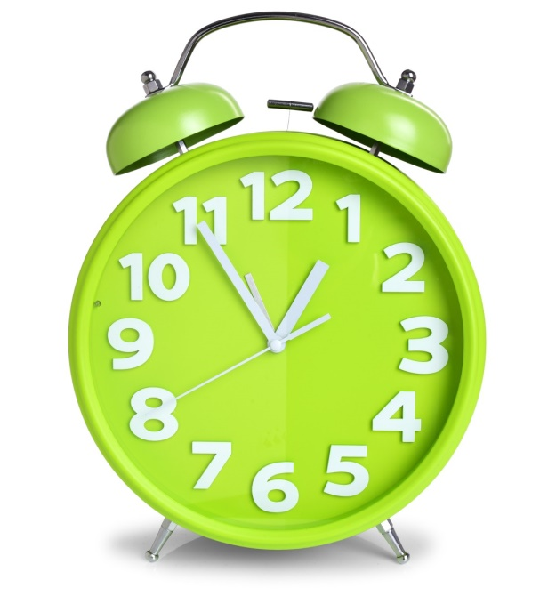 **ZVONENIE**